**User guide for the Poji macro (v1,00)**

Important Information

The macro code and the associated Excel tables have been tested and verified with manually calculated results as much as possible to rule out potential errors. We are quite confident to state that all works as intended. Since hidden errors could still be present, we strongly advise every user to have a careful eye on their results as they are responsible for their own data. If you notice an apparent error or obtain results that do not match with a manual confirmation of the same sample, please feel free to contact the first author at [**r.herzog@uke.de**](mailto:r.herzog@uke.de).

The macro was originally intended, created and optimised to define and analyse podosomes and to refer to podosomes-associated parameters. The macro works by identifying punctate structures and can thus also be used to analyse invadopodia or similar structures. To keep things simple, this manuscript, as well as the saved results tables will only refer to “podosomes”, even though analysis of other structures is possible as well.

If you present or publish data that were obtained by using this macro, please cite the original publication accordingly!

Introduction

The Poji macro is an ImageJ/Fiji-based code that is used to identify punctate structures like podosomes inside cells and uses their localization information to calculate several cell- and podosome-associated parameters. After manual definition of the cell outline by the user (and optionally the definition of podosome clusters), the macro detects podosomes by a local intensity maximum analysis of an appropriately stained protein, like F-actin of podosomes cores. The macro gathers general information about cell properties, like cell area, podosome number and fluorescence intensity in the entire cell area for each analysed channel. A circular area of predefined size is created around each podosome center and the intensity inside this combined area, as well as at single podosomes, is measured. Additionally, a square area can be created around podosome centers to analyse the radial intensity profile of podosomes. Since the macro is dependent on several parameters that need to be manually and empirically defined, the performance and quality of the analysis relies on the user. In this user guide, the different tuneable parameters will be introduced together with some recommendations on their use and a possibility to change preferences in the settings. This user guide relates to the publication: “Poji: a Fiji-based tool for analysis of podosomes and associated proteins” by Herzog et al.; Journal of Cell Science, 2020; doi: 10.1242/jcs.238964. The codes together with premade analysis Excel tables and test images are available at <https://github.com/roherzog/Poji> and at http://www.linderlab.de/tools.

Table of contents

**1 – Before you start** 3

1.1 Installing the macro 3

1.2 Setting up the image files 3

1.2.1 Standard analysis 3

1.2.2 Z stack analysis 4

1.2.3 Optional macro for automatic splitting of planes and channels 5

1.3 Define analysis properties for each cell 6

**2 - Using the macro** 7

2.1 Selection of channels and analysis folders 7

2.2 Choosing analysis and data saving options 9

2.3 Define cell and podosome cluster areas 11

2.3.1 Define cell areas 11

2.3.2 Define podosome clusters 12

2.4 Choose analysis parameters (with preview function) 13

2.5 Automatic analysis 14

2.6 Changing the preferences of the macro 15

**3 – Handling the data obtained by Poji** 16

3.1 Poji output 16

3.2 Fluorescence intensity evaluation 17

3.3 Profile analysis 19

**4 – Summary** 20

**5 - Troubleshooting** 21

1 – Before you start

This section will explain the several ways to install the macro, setting up the analysis images in the right way and also which parameters have to be determined before the analysis is started. In the following sections, images from the test data will be used as visual examples for certain steps of the user guide. The test data show primary human macrophages that are (1) imaged as a single z plane of one cell with two fluorescent channels (F-actin, vinculin), which will be shown for most examples in this guide, and (2) imaged in 10 different z planes of two individual cells with three fluorescent channels (F-actin, vinculin, LSP1), which will be shown for special uses of the macro.

1.1 Installing the macro

There are two ways to run the macro. One is recommended for simple use, the other one can be used to change preferences of the macro. For simple use, install the macro using the Fiji-menu “Plugins>Macros>Install…” and select the “Poji.ijm”-file after downloading it. The installed plugin will appear at the bottom line of the “Plugins>Macros”-menu and will start upon clicking on it. To be able to change preferences, the code has to be opened and edited, by either dragging and dropping the file into the Fiji-menu bar or by selecting “File>New>Script…” and after creation of the macro-window selecting the “Poji.ijm”-file with the command “File>Open…”. In this window, the macro code can be edited and started by pressing “Run” at the bottom of the window. To change preferences, refer to chapter 2.6.

1.2 Setting up the image files

1.2.1 Standard analysis

The Poji macro allows the analysis of different types of experiments but requires only one specific way of image preparation. The data of each fluorescent channel have to be sorted into separate folders as mono-layer images. Therefore, z stacks and channels have to be split into individual images prior to analysis. This can be done manually by the user, but we also added a small code that automatically splits and saves original microscopy data into folders that are labelled with the channel’s name. Please refer to section 1.2.3 for a small guide to this automatic option. There is no preference of data types for the images, but the Poji macro and the code for automatic splitting of channels and z stacks will save their images as .tiff-files, which is why we have always prepared our analysis images as .tiff-files as well. It is important to note, that the Poji macro currently only supports 8- and 16-bit images and up to 4 fluorescent channels at a time.

After data preparation for test image 1, the setup should look like this (note that the folders are labelled with the names of the stained proteins instead of the channel’s numbers):

C:\Users\rherzog\AppData\Local\Microsoft\Windows\INetCache\Content.Word\121a Folder Setup.tif

**Important:** The images in each folder (e.g. the ones in the F-actin and the Vinculin folder) have to be in the same order! The macro will later take the first image from folder 1 (e.g. F-actin) as a reference for podosome detection and analyse it together with the first image of folder 2 (e.g. Vinculin). Changing the order of the data can lead to mismatching of images and to a wrong analysis. Hence, it is recommended to name them identically, maybe only differing in the channel number (Test 1 Z=0 C=1 for F-actin and Test 1 Z=0 C=2 for Vinculin. The data will be labelled like this when using the code for automatic splitting of planes and channels). The results folders that will be automatically created by the macro in a user-defined path will always be labelled with the name of the first channel, hence in this example, the results folder would be called “Test 1 Z=0 C=1” and analysis of both the F-actin and the vinculin image will be saved inside this folder. If it is preferred to give the results folders a specific name, this can be achieved by renaming the channel 1 files, but always keep in mind not to change the original order of files.

1.2.2 Z stack analysis

For the stack analysis, the test image 2 (hyperstack from 3 channels and 10 z planes) is split into single planes that are saved in the respective channel folder as shown for F-actin:

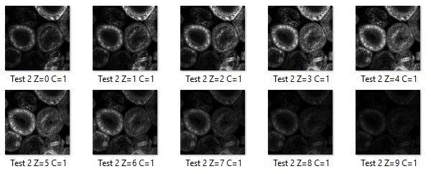

Note the labelling of the images after they have been automatically split by the optional macro (see chapter 1.2.3). This label contains the original image name, the different z planes as well as the channel number. The images in the folders vinculin and LSP1 will be labelled the same way (with C=2 for vinculin and C=3 for LSP1). As mentioned above, the F-actin channel of every cell will be taken as a reference for podosome detection, and all remaining channels are analysed with the detected localisation from the first channel. However, this approach is not productive when analysing a z stack, as both fluorescence intensity and the number of podosomes can vary in different planes of the same stack (see the differences between the images of the same cells in different z stages above). As this will change general parameters of the cell depending on the z plane, the comparable observation of differences between planes will be close to impossible (as any difference could be the result of more or less podosomes being detected, instead of real biological differences). Thus, the stack analysis has to be prepared in a special way to prevent this problem.

The first step is to select a z plane of the F-actin channel that appears to be appropriate for optimal podosome detection, usually the plane where most podosomes are visible or the plane of highest fluorescence intensity are recommended. This decision has to be made based on the scientific question asked. This single specific focal plane is then copied to a new folder (it is recommended to name it appropriately, like “reference”) and duplicated once for every focal plane in the original stack. The complete setup would then be (in a stack with 10 z planes and originally 3 channels): 1 reference folder with 10 times the same image from the optimal F-actin plane, 1 F-actin folder with the 10 original z planes, and 2 folders of the remaining two channels, each with the respective 10 original z planes:

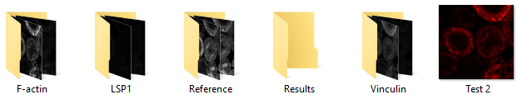

The analysis will now always take the same image as a reference, resulting in the exact number, location and order of detected podosomes, while the original F-actin planes will be analysed as well and can be compared with the results of all other channels. As the macro defines the name of the result folders according to the images in the reference channels, it is recommended to name these images accordingly (e.g. labelling it the same way like all other images and assign C=0 as channel number).

1.2.3 Optional macro for automatic splitting of planes and channels

To save time and prevent the necessity to manually process every focal plane and channel (including splitting, renaming and saving), we also created an optional macro for automatic splitting. The macro can be installed like the main Poji macro but needs less interaction from the user. After starting the optional macro, a message appears that asks the user to first open every image intended for splitting and then to proceed to the next step. Note that these images do not have to be altered (e.g. if the images are opened with the BioFormats Importer of Fiji, do not check the “split planes” or “split channels” function), but are opened as stacks of either channel, planes or hyperstack of channels and planes. Afterwards, the labels for the channels (and thus the labels for the folders) have to be defined. It is also possible to reduce the length of image names, but assigning completely new names to the images has to be done independently of the macro. Subsequently, a path to save the images is chosen and after the user confirmed their selection by pressing the “OK” button on the message window, the images are automatically split, saved and closed. Those images will be “.tiff”-files and their naming will be as: “*Original name* Z=0 C=1.tiff”, with Z and C being the information about z plane and channel number. Please note that the original scale of the images can be changed marginally in the new images as the fourth decimal of the scale factor is rounded. The differences can be ignored in most applications, yet this needs to be mentioned.

**Summary**: Split fluorescence channels and slices from z stacks into individual images and save all images from each fluorescence channel into (equally labelled) folders. This can be done manually, but we also offer the possibility for an automation.

1.3 Define analysis properties for each cell

For optimal detection of podosomes, Poji enables individual adjustment of 4 different parameters. The macro offers a preview function (see chapter 2.4) to test optimal detection conditions after the macro is started. Since it is not possible to zoom into or change the contrast of the preview image for better visibility while the macro is running, some users might prefer to determine these parameters prior to using the macro and just entering the values afterwards. Poji supports the use of both approaches.

The first two parameters that need to be defined are interdependent: The noise tolerance and the number of smoothing steps. The noise tolerance is the intensity value by which a certain pixel has to stand out from its neighbours to be recognized as a local maximum. The lower this value is, the more maxima will be recognized throughout the cell and vice versa. The Fiji-function “Smooth” takes the intensity value of a pixel and replaces it with the average of the adjacent 3x3 pixels. This helps equalizing potentially pronounced intensity differences between neighbouring pixels and can thus be used to improve the detection of the center of podosomes. An unsmoothed image could have one pixel of high intensity just next to the geometric center of podosomes, leading the “Find maxima” function to detect this spot, which will then be defined as the podosome’s center by the macro. Smoothing the image normally leads to the geometric center of podosomes being the pixel with the highest intensity value. This effect is enhanced by smoothing several times. Additionally, it prevents the generation of artefacts in the podosome profiles (see Herzog et al., 2020, Figure 7 A,B). On the flipside, smoothing of an image decreases the intensity differences between neighbouring pixels and thus affects the noise tolerance value of the “Find Maxima”-function. It is therefore recommended to identify a sufficient number of smoothing steps first (recommended by experience are 3-5 steps) and to subsequently define the noise tolerance value.

**Important**:The number of smoothing steps does not alter the original imaging data.The smoothing of the images is only used for better detection of podosome centers. The macro will do this automatically in a duplicated image to localize the podosomes. Afterwards, the duplicate will be closed and analysis will be conducted in the unaltered image.

The last two parameters “circle size” and “square size” concern the size of podosomes. It is recommended that they are defined once and then kept consistent throughout all analyses as this ensures comparability of results. Also, instead of keeping the selections at the same pixel size, a certain size in µm can also be assigned to podosomes and the scale in the images be further used to translate this size to the number of pixels that the area should have. This can also be used to keep sizes consistent in images of different scales. The first parameter describes the size of a circular area that is created around the center of podosomes to measure the integrated density of the fluorescence in each channel. The latter parameter describes the square area around podosome centers that is created for the profile analysis. The two parameters can be of different size. To measure the intensity correctly, the circle size has to be defined precisely, as a small area does not cover the entirety of the podosome (including the ring structure of podosomes), while a larger area also includes background that is not associated with podosomes. The square size can be defined more freely, depending on the scientific question, as a square that is bigger than the area of podosomes can result in a profile of podosomes including their connections to neighbouring podosomes. For both sizes, it is recommended to assign an odd number, as the podosome centers are then placed in the middle of the image and not placed slightly off-center.

**Summary**: It is possible to define analysis parameters before the macro is started as well as using the preview function to determine them within the running macro. Noise tolerance and number of smoothing steps influence the podosome localization detection and have to be optimized for every image. It is recommended to keep the size of the areas created around podosome centers for intensity and profile calculation consistent throughout the whole analysis.

2 - Using the macro

After starting the macro, several dialog windows will be opened that can be used to define analysis folders, adapt the analysis to specific preferences and to enter the predetermined parameters. This chapter will act as a guide through these user interactions, together with explanations and examples of use for every option presented.

2.1 Selection of channels and analysis folders

The first interaction menu after starting the macro asks for a definition of the number of analysed channels (up to four) and to label the corresponding channels:

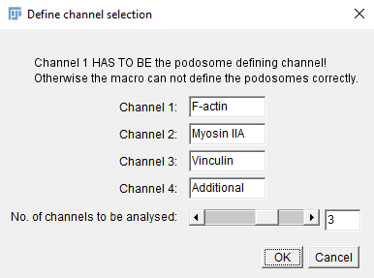

The interaction menu again shows that the first channel is used for the localization of the podosome center and thus has to be a stained podosome core component like F-actin, or another suitable protein. The names of the channels can be edited according to the proteins that were used in the experiment or according to the user´s preference. The slider at the bottom defines the number of fluorescence channels to be analysed. To analyse the test 1 data, the channel settings have to be set as follows:

Channel 1: F-actin; Channel 2: Vinculin; number of channels to be analysed: 2.

Names of unused channels (such as channel 3 or 4 in this case) do not need to be changed, as these channels will not be analysed, and their labels will thus be ignored.

After this definition of channel names and numbers the next interaction menu is opened:

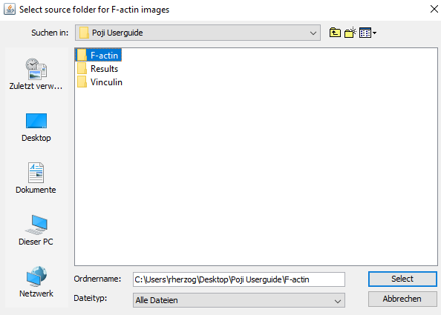

The user is now asked to select the folder where all images from the first channel are saved (single-layer images, as described in chapter 1.2.1). Please note that only the folder needs to be selected, not the individual images. It can happen that the headline of this interaction menu is not displayed when Poji is run on Mac-systems. In this case, the right order of the selections has to be remembered (Selection order is always: Channels 1-4 (depending on how many channels are analysed) and results last). Once the correct folder is chosen, the user is asked to successively choose the folders of all remaining channels and, finally, the folder where the results are to be saved. Please note that upon selection of channel folders, temporary folders are created:

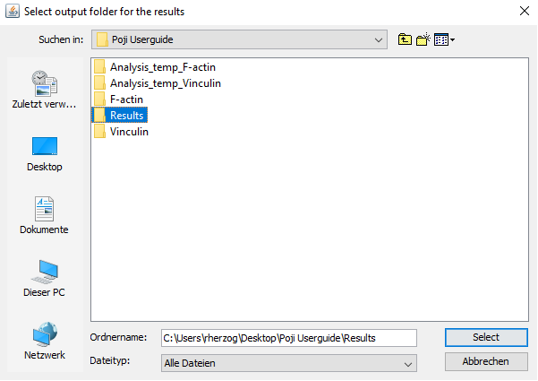

These temporary folders will disappear after the macro analysis has concluded. In case the macro is interrupted by the user or exits due to an error, these folders will remain. It is then recommended to delete the temporary folders before starting a new analysis.

2.2 Choosing analysis and data saving options

Following the selection of the results folder (see chapter 2.1), a dialog window with several options will be created. The options that are selected here will be active for the entire analysis. It is thus not possible to change them individually for single cells within the same analysis. If different options are needed during the analysis, it is best to collect all cells with the same analysis conditions in the same analysis folder and to repeat the analysis with appropriate settings for all cells with different conditions.

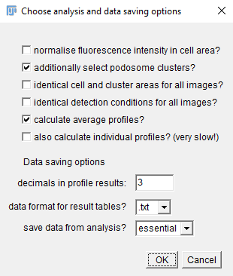

The first six checkboxes directly influence the way the images are analysed, while the bottom three choices define the appearance of the data that are obtained. These options are:

**Normalise fluorescence intensity in cell area**

Fluorescence normalisation is a process where the intensities of all pixels in the selected cell area are automatically adjusted to the maximum bit-range (0-255 in 8-bit and 0-65535 in 16-bit). This can be useful if structures need to be analysed independently from the overall intensity in the cell and at podosomes, as differences in brightness of images are thus equalized. It has to be kept in mind that the normalisation takes place as the second step of analysis (after podosome localization), thus influencing all calculated values in the cell area and at podosomes. Since the normalisation as a non-linear modification of intensity values is only useful in very specific scientific questions and the comparison of original intensity levels is not possible after normalisation, this option is deactivated by default.

**Additionally select podosome clusters**

Manually selecting the cell area is mandatory to define the area of analysis. This is sufficient for cells with a homogeneous podosome distribution like macrophages. However, in cells with inhomogeneous distribution such as dendritic cells or osteoclasts, or for contracted cells with a pronounced actin cortex, the analysis can lead to a high rate of false-positives signals (compare Herzog et al., 2020, Figure 6). It can thus be advantageous to additionally define an outline of the podosome-containing areas of the cell. This is addressed as “podosome cluster” in the Poji macro. As this option can also be individually skipped without clusters selection, it is by default activated. In case none of the cells to be analysed require an additional cluster selection, this option can be deactivated.

**Identical cell and cluster areas for all images**

This option is useful for the analysis of z stacks or the comparison of two identical copies of the same image with different analysis conditions. Since the stack has to be divided into its single planes prior to analysis, a stack will be present in the analysis folder as multiple images. Manually defining cell and podosome cluster areas for each image would be time consuming and probably also lead to variations in respective values from plane to plane. By checking this option, the same areas, once defined initially, will be used for all images in the folder. Since most analyses are done as a comparison of different cells, this option is deactivated by default.

**Identical detection conditions for all images**

This option is mostly used in stack analysis if a reference channel was set up (compare chapter 1.2.2). It follows the same logic as the option described above, that parameters have only to be entered once if they should be used in all images. As, however, the stack analysis is a specialized use of the macro and it is recommended to individually adjust detection parameters for each cell in standard analysis, this option is deactivated by default.

**Calculate average profiles**

This option enables the macro to calculate the average profile of all podsomes in a cell. For this, in addition to the circular area around podosomes for intensity measurements, also a square is created around podosomes (compare chapter 1.3). The square area around podosomes will be copied to a stack of images with one podosome per z plane. Subsequently, a z projection is performed to create one image with the average intensity of all podosomes. A straight line through the image center is placed on the image, and the profile is calculated. The line is rotated 360 times for 1 degree each time, to cover the entire image (values for rotation and degree can be changed in the code. See chapter 2.6). The mean with standard deviation of all 360 measurements is saved as the average podosome profile. In addition to this, the single podosomes will also be normalised to the maximum intensity range before the average z projection is created and the profile is measured. After this step, as a third measurement, the average z projection of the normalised podosomes, is normalised yet again, and the profile is generated. Checking this option will, therefore, activate the calculation of the profile in 3 different versions that can be used, depending on the scientific question. Since this is a powerful and quick feature, it is activated by default.

**Also calculate individual profiles**

**Important:** This option can only be activated **in addition** to the average podosome profile calculation. If this option is activated and the average profile (checkbox 5) is deactivated, there will be no calculation of any profile!

This option is deactivated by default, as it is very time consuming (analysis time for one image with 4 channels increases from ~10 seconds to ~5 minutes). It is only useful for very specific questions and not recommended for universal use. In contrast to the average podosome profile that calculates the profile after an average intensity z projection, this option will take the stack of individual podosomes and calculate the profile per podosome (each profile again being the mean of the 360 measurements after the 1-degree rotation of the profile line). This will lead to two different kinds of result tables, one with the individual podosome profiles and one with the mean of individual profiles, including standard deviation of all measurements.

**Data saving options**

Result that are obtained by the Poji macro can be displayed and saved differently, depending on preferences. First, if the option of profile analysis is activated, the number of decimal places of values in the results table can be determined (note that the result tables for sizes and intensities are not affected by this). The maximum number of decimals is 9. Next, the data type in which the results tables shall be exported can be determined. It is possible to choose between .txt-, .csv- and .tsv-files (comma-/tab-separated values, compatible with Excel), depending on subsequent handling of the data and their potential use in the premade Excel-evaluation tables (.txt recommended for this use). The last option defines the amount of data that are saved during analysis. The option “essential” will save the most important images and tables, while selecting “all” will save additional images and tables that can mostly be used for assessment and confirmation of Poji performance. To decrease file amount and storage size of the results folders, the option “essential” is activated by default. See chapter 3 to learn more about the exported data and the differences between the two data-saving options.

2.3 Define cell and podosome cluster areas

2.3.1 Define cell areas

After confirming the options for the analysis, the macro will open the first image, together with a window that asks to save the selected cell area to the ROI manager before proceeding. Note that selection of more than one area is possible, in case there are several cells in one image. These ROIs will be calculated separately, hence one image can be used for the analysis of multiple, independent cells. The results of several cells per image will be given as “*Name of your sample*”-Cell 1 for the first cell and accordingly numbered for all other cells. However, it is mandatory to select at least one area and adding it to the ROI manager to be able to proceed:

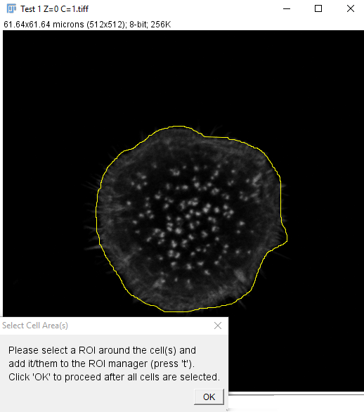

During this step, Fiji can be used without limitations. It is thus possible to select the “Freehand Selection”-tool in the menu bar to define cell areas. Note that any changes made to the image in this step will not be saved, allowing to zoom into the image, change colours and even to adjust the brightness, in case this is necessary for better visibility of the cell. It is also possible to load an existing ROI-file into the ROI manager. This can be especially useful for repeating and comparing an analysis with different parameters in the same cell area. For information on where to find the ROI-files after the analysis is conducted, see chapter 3. Additionally, it is possible to use an automated cell segmentation tool of choice prior to starting Poji and load the ROI output of automated cell detection into the ROI manager during this step. Subsequently, the next image from the analysis folder is opened and the user will be asked again to draw ROI(s) around every cell in the image to be analysed. Selecting the option to use the same ROIs for every image, results in having to define the ROI(s) only once in the first image. The user will then be guided to the next option immediately.

2.3.2 Define podosome clusters

After defining the last cell ROI, the user will be guided to the option to additionally choose areas for the podosome clusters, in case this feature is activated in the analysis options (checkbox 2, see chapter 2.2). The current image will be opened, where the previously defined cell ROI is permanently marked, together with the request to manually define podosome clusters within the marked cell. In contrast to the mandatory definition of cell area, proceeding without selecting a cluster is possible, as well. Podosome detection will thus be done in the entire cell area. It is possible to select more than one cluster per cell, which can be especially useful to analyse cells with several areas of podosome formation. Still, these clusters will be analysed together as one podosome-covered area, hence there will be no subdivision of the results into cluster 1 and cluster 2. In case such a division is necessary, the analysis of the same cell has to be conducted multiple times, with each time selecting another cluster.

**Important:** It has to be emphasized that only the podosome clusters in the marked cell have to be selected! If more than one cell area per image was defined, the same image will be opened multiple times in this step, each time marking a different cell, and the user will be requested to select the podosome cluster area for only one cell at a time:

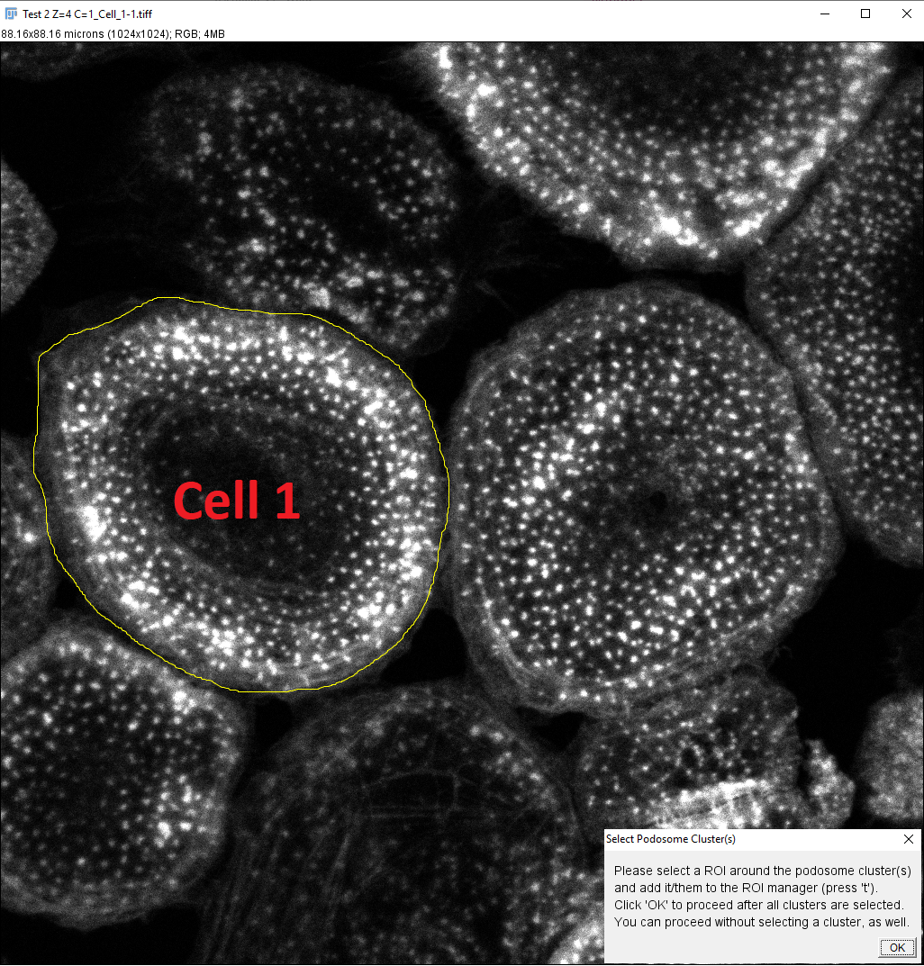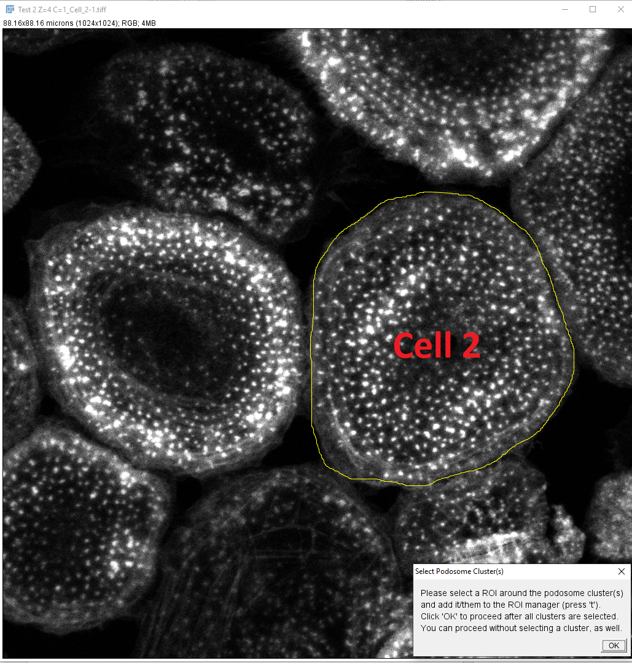

2.4 Choose analysis parameters (with preview function)

After selecting both cell and podosome cluster areas, the user will be guided to the last adjustment step of the macro. The image of the current cell with marked cell area is shown, and a window to enter the detection and analysis parameters is created, showing default options. These are the 4 values that can also be determined prior to starting the macro (see chapter 1.3). Note that the value for the square size will only appear if the calculation of podosome profiles was activated (see checkbox 5 in chapter 2.2):

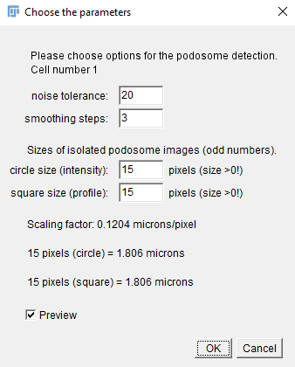

In the upper part, the detection parameters are entered for both the noise tolerance as well as the smoothing steps. If no smoothing of the image prior to the maxima detection is desired, just enter a “0”. Still, users should be aware that podosome detection on an unsmoothed image could lead to artefacts (compare Herzog et al., 2020, Figure 7 A,B). Note that Fiji cannot be used while this window is active. In the lower part, the sizes for both the circle size (for intensity measurements) and the square size (for profile calculation) of the podosome isolation can be entered. Note that the value is the number of pixels, and that it is recommended for this to be an odd number, in order to place the podosome center exactly into the middle of the isolated images. Entered values have to be >0, as the macro otherwise exits with an error message. Below this selection, the current scaling factor of the image is visible, combined with calculations that show the current sizes multiplied with the scaling factor, indicating the actual sizes of the selections in microns. This can be useful to keep the sizes of the selections similar when using images of different sizes and scaling factors. The last checkbox is the activated preview function. If the “OK”-button is clicked while the “preview”-option is checked, the current image will be reopened, with circular and square selections of respective size around the detected podosomes:

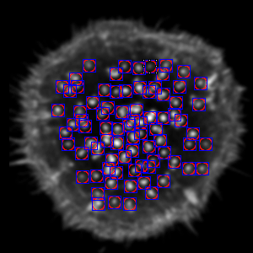

The window to choose analysis options now shows the updated, chosen values, including the calculated area around podosomes in microns (circles in red and squares in blue. The potential difference in sizes can be shown in this step). As long as “preview” is checked, pressing “OK” will always reopen the same image with the respective podosome detections. When detection performance is optimized, the “preview”-checkbox has to be unchecked in order to proceed. By pressing “OK” now, the current settings are automatically saved for the respective image, the next image is opened and parameters can be optimized as well. If the parameters were determined before the start of Poji, the preview function can be unchecked right away and values can be entered without further testing. Please note that the preview function is activated by default whenever a new image is opened, to prevent saving of wrong settings for the next image by mistake. If the preview function should be disabled by default, please refer to chapter 2.6.

2.5 Automatic analysis

After all parameters are entered for all images, the macro starts automatically and shows a progress bar with the name of the currently analysed image:

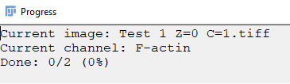

The progress bar is not only used to estimate the duration of the analysis, it is also the indicator that the macro is still running, as this is the last window that will be closed when the analysis is complete. It is possible to use other programs on the computer while Poji is active, but this, of course, increases the likelihood of mistakenly interrupting the macro. If the user normally uses Log-windows and result-tables in Fiji in full screen, it is recommended to decrease these windows in size before starting the macro. As the analysis repetitively opens and closes those windows automatically, the screen might be constantly blinking when windows are opened and closed in full screen, which might be irritating and could even slow down Poji. After the analysis has ended, all windows are closed and the progress bar disappears. The data have now been saved in the assigned results-folder, and all temporary files (see chapter 2.1) are automatically deleted. If the macro was, however, interrupted by the user or by an analysis error, it is recommended to delete the temporary-folders and empty the results-folder by hand before restarting the macro, as the already saved data in these folders can interfere with the restarted analysis.

The different kinds of results that are obtained and their handling will be discussed in chapter 3.

2.6 Changing the preferences of the macro

As shown above, the Poji macro offers many options and parameters that can be adjusted to ensure optimal analysis, depending on quality of the data and the underlying scientific question. These parameters might differ drastically from data set to data set. It might, however, also be that a certain option is always required, but not activated by default. In this case, always having to change the data to already known preferences can be time-consuming. To prevent this, several comments have been added to the macro code, which help to change the options that are shown by default to the users´ individual preferences. This requires the user to open the code for editing (see chapter 1.1). The following lines allow the adjustment of shown values:

Lines 11-15: Change default labels of the channels and the default number of channels to be analysed.  
Lines 56-65: Change default de-/activation of analysis options and default values for data saving options.  
Lines 214-217: Change the detection parameters and selection sizes that are shown by default.  
Line 260: De-/activate the preview function by default.   
Lines 352, 353: Change the number of rotations and the degree value for each rotation of the profile line. Default is set to 360 rotations with 1 degree turning per rotation.

3 – Handling the data obtained by Poji

Depending on the options, adjusted in chapter 2, the Poji macro will give out data differently. This chapter is intended to show which sets of data can be obtained, what they can be used for and how they can be handled further. It has to be emphasized that the results are structured in a way so that they can be optimally used in the provided Excel tables. It is, however, possible to take only few values that are needed and to process them individually without ever using the Excel sheets.

3.1 Poji output

After analysis is concluded, several data files and folders will be present in the results folder that was assigned by the user during the macro setup. There are up to 4 data tables present in this folder (one for each fluorescent channel). These tables were created in the selected data type (.txt, .csv or .tsv) and include the names of the images that were analysed, together with respective data of cell size in scaled units, the combined fluorescence intensity of the cell area, the size and fluorescence intensity of the podosome covered area, as well as the intensity value for all single podosomes and can be used for the intensity evaluation table. Additionally, folders with the names of all analysed images are present, which contain results that were saved for each cell in the images.

**Results folder for each cell**

These folders are created for every cell that was selected by the user during the macro setup. Each folder contains up to 3 subfolders together with the parameters table. This table is especially useful to confirm that the right settings were used, as well as a guidance to use the right parameters when repeating the same analysis. The parameters table also lists general cell values like cell area in scaled units and podosomes number, but mostly consists of technical values, including the selected noise tolerance, number of smoothing steps, the sizes for podosomes selection, number and degree of rotations of the profile line, together with the scaling factor of the image, as well as information about bit depth of the image and if the source image was normalised during the analysis. The 3 subfolders are labelled “Images”, “Profiles” (this folder will not be created if the option to calculate profiles was deactivated), and “ROIs”.

**A - Images**

The first subfolder inside every individual results folder contains several images that were obtained by the analysis. The number of images depends on either the “all”- or the “essential”-option of data saving in the macro setup having been activated (compare chapter 2.2). Always saved are the images of the isolated cell areas, the original source images and the isolated podosome stacks (circle selection for intensity) for each channel. If the “all”-option was activated, the additionally saved pictures are the isolated podosomes covered area and the podosome stacks (square selection for profile), both original and normalised for each channel. Note that the original scale has been removed from all images, apart from the source images. If images were normalised during analysis, the source image will be saved after normalisation as well.

**B - Profiles**

This second folder is only present if the option to calculate profiles was activated during setup. It contains different subfolders and data, depending on which options were activated prior to analysis. There are 3 data tables in the profile folder that represent the radial fluorescence intensity calculations of the average intensity z projection of all podosomes. Those values were calculated from the original z projection of unaltered podosomes (original), from a z projection after all podosomes were normalised individually (stack normed) and from a normalised z projection after all podosomes were normalised individually as well (z-projection and stack normed). Note that these 3 different conditions are always calculated, independently from the normalisation of the whole cell (compare checkbox 1 in chapter 2.2). The values in the tables represent the mean of the 360 different measurements across a profile line that were calculated after the profile line was rotated by one degree teach time, to cover the entire image. One subfolder in the profile folder is also labelled “Images” and contains the underlying z projections in which the profiles were calculated. A second subfolder in the profile folder is only present if the option to additionally calculate individual profiles was activated. This subfolder contains tables with the individual podosome profiles (mean of all rotations) for every channel and with the mean of all podosomes together with standard deviation, both from original and from normalised podosomes (original and normed). Note that the mean of all podosomes in this folder should be the same value as in the previously mentioned tables in the profile folder. However, there can be a small difference in values due to several ways of calculating the values (z projection of all podosomes prior to calculating profile compared to calculating profiles of all podosomes and averaging afterwards). The user can decide which results are used to compare profiles, but should be aware of the potential, small differences. If the option to save all data has been activated two additional subfolders will appear, one for the general profile analysis and one for the individual profiles, if they have been calculated. These additional subfolders contain the information of profile measurements for each rotation of the profile line. Together with the single values, they contain tables that list the mean of all rotations including standard deviation. The mean of all rotations is the value that is given out in the previously mentioned tables of individual podosomes or the profile after z projection. These tables can be useful for more precise comparison between profiles as they offer the possibility to obtain not only averaged but also single values, including standard deviation.

**C - ROIs**

The third subfolder of the results folder for each cell contains different ROIs that were manually and automatically selected. Here, the ROI of the manually selected cell area as well as the optionally selected podosomes cluster areas are saved together with the circle ROIs of single podosomes for intensity measurements and the square ROIs of single podosomes for the profile calculation. Additionally, the combined podosome ROI, which represents the area of circular ROIs, where potential overlaps have been deleted, is saved. All these ROIs can be used in the original source image (form the “Images”-folder) to assess if all areas were defined appropriately. They can also be loaded into the ROI manager when analysis is repeated, to analyse the exact same areas again.

3.2 Fluorescence intensity evaluation

The fluorescence intensity, together with general cell and podosome parameters, can be automatically calculated in the “intensity evaluation” table. This is used to compare two fluorescence channels with up to 30 different cells per channel. For this evaluation, the results tables from the general results folders are needed. The following paragraph will describe where the data have to be entered and which results can be obtained. When a table is opened, the “Extraction for comparison” section is shown (Fields A7-F51). This section is a summary of all information and shows the mean of all measurements that can be obtained by this tables in the Fields F8-51. These values can be used subsequently for the “comparison of intensity evaluation” table.

In fields B1 and B2, the labels for first and second channel can be defined, which automatically renames all data points and graphs in this table. The data for the first channel (saved in the user-assigned output folder for results) can now be copied and entered into the field H3 (the cell labels in the results table will overwrite the placeholder names in the evaluation table). The data for the second channel are copied into the field DH3. A maximum of 30 different results per fluorescent channel can be handled by this table. To analyse more than 30 cells, the results have to be split and calculated successively in a copy of the evaluation table. The mean results can be extracted (F8-F51) and compared in the “comparison of intensity evaluation” table afterwards. In case less than 30 different cells have been analysed, there will still be empty rows left in the evaluation table. It is recommended to clear those lines throughout the whole Excel table, as separate values will just show error messages (Caution: do **not delete** these rows, just **clear** them. Clearing has to be done for all empty lines in the lines H-AK, AQ-BT, BY-DB, DH-EK, EQ-FT, FY-HB, as well as in the lines HH-IK, IN-JQ, and JV-KY), After data tables for both channels have been copied, a variety of data sets has been calculated automatically, which will be described in the following:

AL3-AM11 and EL3-EM11: mean and SD of general parameters like size and intensity in cell and podosomes covered area for both channels, respectively.

AQ6-DD71 and EQ6-HD71: Automatic calculation of intensity distribution at podosomes in the cells, both for absolute number of podosomes, as well as percentage values in relation to the total number of podosomes. These data sheets show the number of podosomes with a certain intensity and plots these graphs as histograms below the tables. This can be used to assess differences in protein association to podosomes. Note that the number of podosomes with a certain fluorescence intensity is binned in groups with intervals of 1000 a.u. per group (Line AP6-71). The range of this binning can be adapted by manually adjusting this range. The range for all 4 histograms in this Excel sheet (2 for each channel) can be edited in the line AP6-71, as all other histograms refer to this line. For use of the intensity distribution histogram, see (Herzog et al., 2020, Figure 2C,D)

AQ73-BU98 and EQ73-FU98: Values for podosome number, as well as (again for more clarity) intensity for cell and podosome covered area, together with calculated data like intensities in podosomal area in relation to cellular intensity and the mean of intensity per single podosomes, both absolute and relative value are shown. The corresponding graphs for these values are on the right side of the tables for each channel.

HH6-LA59: This section shows the relation of channel 2 to channel 1 by first dividing all single values of channel 2 by all single values of channel 1, respectively, and then again by binning them for a ratio distribution histogram. Note that the binning range for this table has to be adapted separately in Line IM6-25.

IM64-JS82: Comparison of general parameters like sizes of cell and podosomal area, together with the calculation of podosome density and the mean of the ratios of intensity values from channel 2 and 1. The corresponding graphs are shown below these tables.

If all values are entered correctly, the extraction section (F8-51) should display no more errors and only values. This line now contains all mean values with standard deviation that were calculated throughout the entire table. They can be copied and used in the “comparison of intensity evaluation” table, where they are inserted into line F-O4. In this table, the channels can again be labelled correctly in Fields B1 and B2, and the table allows the comparison of 10 different intensity evaluation tables. To compare the histograms of intensity distribution, the mean and standard deviation section in the original (e.g. lines BU6-BV71 from the evaluation table) have to be copied to the T3-U68 in the comparison table. The corresponding graphs are at the lower part of the results tables.

3.3 Profile analysis

The last Excel table helps to automatically create histograms of the profile analyses. This can be used for both the individual podosomes profiles (note that standard deviations cannot be added to the Excel table), as well as for the standard method of profiles calculated after average intensity z projection of all podosomes. The respective results tables in the profile folder are needed for this analysis, as well as the values for scale factor and the square selection size, both of which can both be found in the “Parameters” table. These have to be adjusted first upon opening the Excel table. For this, the size of the square selection has to be entered in field A5 (note how the x-values in A6-50 are automatically adjusted), as well as the respective scale factors above the individual tables (e.g. into field C2 for the first histogram, field H2 for the second, etc.). The scalefactor together with the squaresize is used to automatically calculate the x-axis of the histograms. Note that the x-axis in line A is, in most, cases longer than the size of the square would require. For every value above the square selection, rows from the Excel table have to be **deleted** (note that this time the lines can also be **removed** completely and not just **cleared**).

Example: The square size is 15. After entering this value, the x-axis will be stretched from -7 to 37. Select all rows that are above 7 (select the entire rows 21-50) and delete them. The x-axis will now be set optimally. Afterwards, scroll down to the two tables underneath. Many rows that now show an error message have to be deleted until only an x-axis with 15 values, from -7 to 7, is left in all 3 tables.

Now the values can be entered by copying data from the profile tables and entering them into the table. The column headers again have to be overwritten (e.g. data has to be pasted into D5-G5 for the first set). This is now repeated for all profile values that were calculated. The name of the cells can also be added to the tables (e.g. C4). The values only have to be added to the upper tables, as these are absolute intensity values that are calculated by Poji. The second table automatically normalises these values, by setting the minimum and maximum for each channel to a range of 0%-100%. Thus, intensity comparison is no longer possible, but the profile structure can be enhanced and better compared. The third table at the bottom is normalised comparably, hence it sets the minimum and the maximum of all four channels to 0% and 100%, respectively. This ensures relative intensity comparability within one data set, but could mask existing differences between different cells.

The calculations of mean and standard deviation of all the tables are found on the very right side of this Excel sheet, where they are shown together with the respective histogram. Note that the histograms always show the intensity (absolute or normalised values) on the y-axis and the distance to the podosome center on the x-axis. It has to be noted that also the mean of the x-axes is calculated, which is not correct theoretically, but if square sizes and scaling factors were kept consistent, or at least as close as possible, the error that is created by this will be minimal and can be ignored.

4 – Summary

The Poji macro was designed to help analysing podosomes, by gathering detailed information about size, composition and association of different proteins to podosomes and to connect this with general properties of the cell and the podosome covered area. This chapter is intended to summarize the points that were extensively described in the other sections and to be used as a concise overview about the actions that have to be performed to successfully work with the Poji macro:

|  |  |
| --- | --- |
| **Before using the macro** | |
| Download and install the Poji.ijm file | Do once |
| Optionally change the preferences in the Poji macro |
| Split fluorescence channels and z planes of the images | Do for  every  experiment |
| Save all images from the same channel in one folder |
| Make sure that the data in all folders are in the correct order |
| Determine noise tolerance and smoothing steps for every image* |
| Determine selection sizes for the intensity and profile analyses* |
| **Using the macro** | |
| Define channel names and select folders for analysis | Do once |
| Adjust the analysis to own preferences by de-/activating options |
| Manually define cell areas and add them to the ROI manager | Do for every image |
| Optionally define podosome clusters manually and add them as well |
| Enter the detection parameters and podosome sizes (and optimize them with help of the preview function) |
| **After using the macro** | |
| Insert intensity values into the intensity evaluation table | Do once per channel |
| Insert profile values into the profile evaluation table | Do for every cell |

* can also be done while using the macro, see chapters 1.3 and 2.4.

5 - Troubleshooting

Problem: The results do not match my manual confirmation. How can I check for potential errors in analysis?

Solution: The most valuable information will be the “Parameters”-file that is saved in the results-folder (see chapter 3). It can be easily used it to check if there was an error in entering parameters. If the parameters are correct, checking the number of detected podosomes is the next step to assess if the macro worked as intended. Differences in detected podosomes (even though the parameters were correct) could be due to the image being processed during the adjustment of the parameters. If an image with low fluorescence intensity was used and brightness or contrast were changed for better visibility, then the determined noise tolerance results in a different number of detected maxima than the same value in the original image. Additionally, the “Pictures”-folder should be checked, in case some data were not in the right order, and the different channels did not originate from the same sample. Also, the ROI-files in the original image should be checked, to see if all areas were defined correctly and fit to the used data. If the error still persists and is consistent throughout several samples, please contact the first author at [r.herzog@uke.de](mailto:r.herzog@uke.de).

Problem: The macro states that a certain table was not found and exits with an error.

Solution: This mostly happens when the macro was not able to detect any signal in the selected area whatsoever. It tries to select a certain results table, but without any podosome detected, results tables have never been created. If you are sure that there are podosomes inside the cell, check your settings again. It might be that you did not set cell or podosome cluster area correctly, or that you did not enter the correct values for noise tolerance or smoothing steps for this cell. Even when the macro is aborted due to this error, the “parameters”-table should still be saved in the corresponding result-folder. It should be used to check if all values were entered correctly.

Problem: I chose consistent microscopy settings throughout my experiment, and in one condition, the channel of my core protein is barely visible, so that optimal podosome detection is not possible. Is an analysis still possible, since it relies on initial podosome detection?

Solution: Yes, with a small workaround, analysis is still possible. Like in the stack analysis, you can create a “reference” channel. For this, you can copy the image of your core protein channel and preprocess it to render podosomes clearly visible (for this, you can, among others, adjust brightness, normalize the image or subtract background). Then start the analysis with the preprocessed images as channel 1, and with your original, not processed images as channel 2. By doing this, the macro will detect the podosomes in the processed image and use these positions to analyse the original image.

Problem: The macro opens the console window throughout the analysis and gives out a warning message, but the analysis is not interrupted. Are my results still valid?

Solution: This is a problem that only occurred rarely to me as well (sometimes, during very large analyses with >150 images and ~300 podosomes per cell at once), and that I was not able to solve myself either. This problem did not occur consistently, and even repetitions of the same analyses with warnings sometimes worked without warning, hence this problem does not seem to be sample-dependent. Results of the repetitions without these warnings, to my knowledge, were the same as the results from original analysis with warnings, so I do not have an indication that results are altered by this. Still, preventing these warnings would be nice, so if you have an idea how to solve this, please also contact me.

Problem: I want to analyse a z stack, but my first image is not opened, so the macro just quits and never starts the analysis.

Solution: This is a rare error that might happen when you have not only images but also other folders inside your image folders, and if this subfolder is the first in the alphabetical order. Since the stack analysis opens only the first item in a folder, and the macro is programmed to not open any folders, the macro tries to open the first item, but skips it and afterwards just quits. Either don’t have any folders inside your image folders (recommended anyway), or rename the subfolder, so that it does not come first in the alphabet, and this problem can be avoided.